**IE 251 CASE STUDY 1**

Case Group Number 38

Student Number/ Name / Surname

2436582      Fehmi Arda Yılmaz

2530103      Burak Baki Bakır

2528990   Erdoğan Mert Oktay

**IE 251: Case Study I Report**

**Content**

**Content 2**

**Introduction 3**

**Report 4**

**Assumptions 4**

**Indices 4**

**Decision Variables 5**

**Parameters 5**

**Objective Function 5**

**Constraints 6**

**Results 7**

**Discussion 7**

**Conclusion and Recommendations 9**

**Appendix 10-13**

1. **Introduction**

International Coal (IC) is an electricity generation company with a 1,000 MW coal-fired plant in the UK. They purchase different fuels to maximise their profit while fulfilling the constraints. Because various kinds of coal have varied compositions, calorific values, and pollutant levels, they must be used in combination.

IC wants to optimize their purchases for five months, from June to October. IC can order three types of coals for burning in September and October, and use its stockpile coal (including coals previously ordered and en route) of 600,000 tonnes and wood chips (a kind of biomass) for all five months. Because biomass is more difficult to manage than coal, it is only 10% effective, whereas plant is 35% effective. Also, usage of biomass is encouraged by the Department of Trade and Industry in UK. For each MWh of biomass-generated electricity, IC receives a supplement (known as the Renewables Obligation Certificate, ROC, supplement) of £45 per MWh generated from renewables.

Burning coal produces carbon dioxide (CO2), nitrogen oxides (NOx), sulphur dioxide (SO2) and particulates. IC has to pay for CO2 emissions at the market rate (as if it were additional fuel cost) of 15 Euros per tonne of CO2 emission, and the CO2 emission per MWh of power produced is taken as 0.8 tonnes. IC is allocated a limit for SO2 emission (called a “sulphur bubble”) of 30 kilo tonnes until the end of October, of which 30% is left for this sulphur year. Reduced SO2 and NOX emissions can be achieved using flue-gas desulpherization (FGD) and scrubber technologies.

Power is sold to electricity markets, and fuel is purchased according on the future prices in these markets. Each month consists of four price bands: weekend or weekday, and peak or off-peak, where a 12-hour block constitutes a peak time. As a result, each month has four future prices. IC is charged a transmission tariff of 65p per MWh for power distribution.

IC is highly concerned about SO2 emissions. It may be cost-effective to invest in FGD, or SO2 emissions may become tradable in the same way that CO2 is, both of which would have a significant impact on plant operations.

The data regarding the coal types, electricity market forward prices, and their related characteristics and values are provided in the tables below.

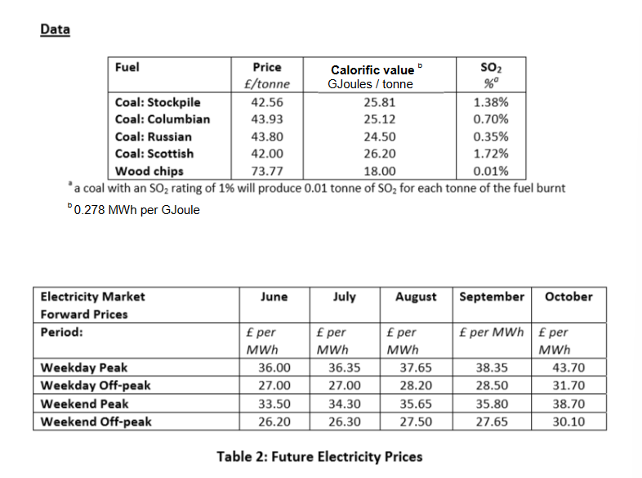

1. **Report**
   1. **Assumptions**

First of all, Proportionality, Additivity, Divisibility, Certainty assumptions must be hold. Also, it was assumed that there are no fixed costs of firing up furnaces using fuel oil and There are no inventory costs.

* 1. **Indices**

**i:** month in which the fuel is bought {1, 2, 3, 4, 5} (1: June, 2: July, 3: August, 4: September, 5: October)

**j:** fuel type {1, 2, 3, 4, 5} (Coal: Stockpile, Coal: Columbian, Coal: Russian, Coal: Scottish, Wood chips)

**k:** period {1, 2, 3, 4} (Weekday Peak, Weekday Off Peak, Weekend Peak, Weekend Off Peak)

* 1. **Decision Variables**

$x_{ijk}$**:** amount of fuel burned in month i type j in all periods k

* 1. **Parameters**

$W_{j}$**:** cost of fuel j (Appendix 1.1)

$C_{j}$**:** calorific value of fuel j (Appendix 1.1)

$S_{j}$**:** sulfur percentage of fuel j (Appendix 1.1)

$H_{j}$**:** efficiency of fuel j (Appendix 1.2)

$P_{ki}$**:** electricity price in month i at period k (Appendix 2.1)

${ E}_{ki}$: number of period type k in month I (Appendix 2.2)

$N$**:** Pound-Euro Exchange Rate = 1.5 (Appendix 3.1)

$G$**:** MWh energy per calorie = 0.278 (Appendix 3.1)

$T$**:** Transmission rate = 0.65 (Appendix 3.1)

$R$**:** Supplement = 45 (Appendix 3.1)

$U$**:** Plant capacity = 12,000 (Appendix 3.1)

$D$**:** CO2 Emission Rate = 0.8 (Appendix 3.1)

$O$**:** CO2 Emission Price = 15 (Appendix 3.1)

* 1. **Objective Function**

$$\sum_{i=1}^{5}{\sum_{j=1}^{5}{\sum_{k=1}^{4}{x_{ijk}H_{j}C_{j}P_{ki}G}}}-\sum_{i=1}^{5}{\sum_{j=1}^{5}{\sum_{k=1}^{4}{x_{ijk}}}}W_{j}-\sum_{i=1}^{5}{\sum_{j=1}^{5}{\sum_{k=1}^{4}{x_{ijk}}}}H_{j}C_{j}GDON^{-1}-\sum_{i=1}^{5}{\sum_{j=1}^{5}{\sum_{k=1}^{4}{C_{j}}}}H_{j}GT+\sum_{i=1}^{5}{\sum_{k=1}^{4}{x_{i5k}}}H_{5}C_{5}GR$$

Income from the electricity sales, cost of the fuel purchases, penalty for CO2 emission, cost from transmission rate, and Renewables Obligation Certificate supplement; respectively according to the sums.

* 1. **Constraints**

Sulfur Bubble Constraint

$$\sum_{i=1}^{5}{\sum_{j=1}^{5}{\sum_{k=1}^{4}{x_{ijk}S_{j}≤9,000}}}$$

IC is normally allocated a sulfur bubble of 30 kilo tonnes for the year, of which 30% is available (9,000). Amount of fuel burned in month i type j in period k and sulfur percentage of fuels are multiplied in a summation that includes all i, j, and k values.

Stockpile Constraint

$$\sum_{i=1}^{5}{\sum_{k=1}^{4}{x_{ijk}}}≤600,000 for ∀j=\left\{1\right\}$$

Stockpile coal is previously ordered and en route. It is paid for once it is used by IC, during all months and periods (that is why $x_{ijk}$ is used). The current coal stockpile at the plant is 600,000.

First Three Months Fuel Type Constraint

$$\sum_{i=1}^{3}{\sum_{j=2}^{4}{\sum_{k=1}^{4}{x_{ijk}=0}}}$$

During the first three months, only stockpile coal (j=1) and wood chips (j=5) can be used, which is why the amount of other coal types (j=2,3,4) used should be equal to zero for first three months (j=1,2,3).

Plant Capacity Constraint

$\sum_{j=1}^{5}{{(x}_{ijk}H_{j}}C_{j}G{- E}_{ki}U)≤0$ for $∀$ i = 1, 2, 3, 4, 5 $and for ∀k=1,2,3,4$

Capacity of the plant is 1,000 MWh. We summed up the energy produced during the entire weekdays or weekends in each month and produced energy will be lower than factory’s hourly capacity multiplied by the number of weekdays or weekends in that month.

$$Sign Constraint$$

$x_{ijk}≥0$ for $∀$ i = 1, 2, 3, 4, 5 $for ∀j=1,2,3,4,5$ and $for ∀k=1,2,3,4$

Theamount of fuel burned in month i type j in period k cannot be negative, which requires a nonnegativity sign constraint.

* 1. **Results**

The linear programming model was solved using GAMS. The objective function yielded the maximized result of £23362276.275889. The optimal values for the variables are given in the table below which show how many tonnes of fuel type used in month i period k

**Table 1.0**

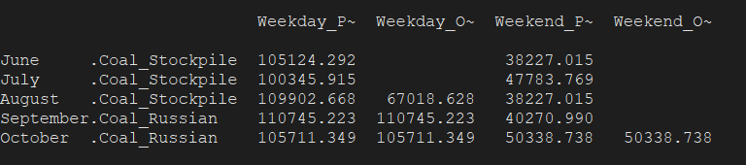

* 1. **Discussion**

The amount of sulfur bubble owned is 9,000 tonnes and 1,978.248032 tonnes is used in the 1st month. In 2nd month, which is July, the amount used is 2,044.189634, and for the 3rd month, it is 2,969.046697 tonnes. For the 4th and 5th months, the numbers follow as 916.1650274 and 1,092.35061, respectively. Remaining sulfur amount in hand is 7,021.751968, 4,977.562334, 2,008.515637, 1,092.35061 and 0 for each month from the start.

If unit CO2 trading cost were to increase by €1, the net profit of IC decreases. Basis will not change until it becomes €16.17. However, £1 of increase in ROC does not cause any change in the net profit, therefore having a reduce cost of zero. Upper limit of ROC constant is £401.926324 after this basis will change. There is no lower bound for ROC

£1 increase in the price of Russian coal decreases the net profit by £468,688.7256, increase in the price of Russian coal increases the net profit by £607,505.0403. Shadow prices for the Colombian coal and Scottish are also zero. Decreasing the price of Colombian coal by £1 would increase the net profit by £98,312.25573 this means basis will change when there is £1 discount. Lower and upper bounds of fuel types as follows

Coal: Colombian lower bond is £43.292987 but there is no upper bound.

Coal: Russian upper bond is £ 44.42632 but there is no lower bound.

Coal: Colombian lower bond is £40.4654048but there is no upper bound.

If IC could allocate one more ton of sulfur bubble, it could increase its net profit by £473.6354. However, any increase in the right-hand side of the sulfur bubble constraint makes it leave the allowable range, thus requiring changing the fuel types that are bought. Note that this is a binding constraint since all available sulfur bubble is used by IC. The Sulphur constraint can be increased up to 9733 tonnes. After this limit basis will change and Coal: Scottish will be used. All available 600,000 tonnes of stockpile fuel are not used (only 506,629.3017 tonnes are used, therefore an allowable decrease of 93,370.6983), so increasing it would make no difference in the net profit earned by IC. There is no limitation on how low the right-hand side can be on both of these constraints.

If IC could increase its plant capacity by 1 MWh, it could increase its net profit by £19,099.55726. Since plant capacity has twenty constraints, allowable ranges for each of four time period in a month with their shadow prices are provided in the appendix 4.1 part of the report.

If the efficiency of wood-chip biomass could be increased to 68% by the use of advanced chemical procedures, IC would increase its net profit from the electricity sales remarkably by £4,105,294.86. Then profit will be £27467571.135474. In this case, the only types of fuel that are used would be Scottish coal and wood-chip. (Amount of uses showed in Appendix 3.2) ~79.52% of the total electricity generated would be with the use of wood-chip biomass, and ~ 20.47% with coal.

* 1. **Conclusion and Recommendations**

In this case, we aim to maximize the profit of IC for 5 months. There are restrictions for the amount of sulfur bubbles, stockpiled fuel and the capacity of the facility. There are also supplement on the use of wood chips. To get the objective function, we sum income from the electricity sales, supplement for renewable resource use which is 45£ and, we deduct the cost of the fuel purchases, penalty for CO2 emission, transmission cost which is a 0.65 scalar. 15€ per ton cost incurred as a result of CO2 production. This company needs to increase the efficiency of the plant. In this way they can get a much higher profit now.

In addition, you need to use flue gas desulfurization (FGD) and "scrubber" technology. Sulfur bubble restrictions are mandatory, reducing SO2 emissions. The sulfur bubble limit is one of the binding boundaries. If we had increased the limit, we could significantly increase our profits (473 pounds per ton of sulfur bubbles). In addition, there is a possibility that SO2 will become a direct cost so that SO2 emissions will become very costly for IC. It would be a wise choice for IC to invest in FGD to increase its current and future earnings.

1. **Appendix**

**Table 1.1**: $W_{j}=$ Cost of fuel j, $C_{j}=$ Calorific value of fuel j , ${,S}_{j}=$ Sulphur percentage of fuel j

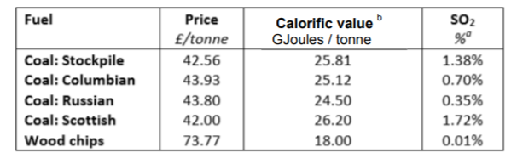

**Table 1.2** H(j) = Efficiency of fuel j

|  |  |  |
| --- | --- | --- |
| H(j) Efficiency of fuels | Coal: Stockpile | 0.35 |
| Coal: Columbian | 0.35 |
| Coal: Russian | 0.35 |
| Coal: Scottish | 0.35 |
| Wood chips | 0.035 |

**Table 2.1** Pki= Price at Month i and Period k

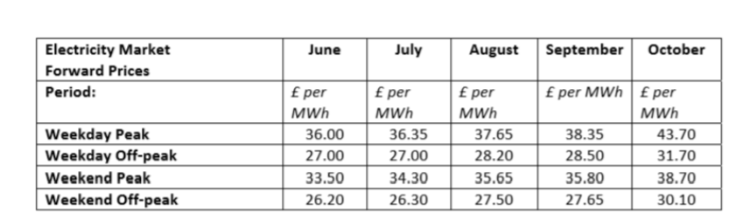

**Table 2.2** Eki = Amount of days in month i period k

|  |  |  |  |  |  |
| --- | --- | --- | --- | --- | --- |
| Table E(k,i) Weekdays or Weekends in month k | | | | | |
|  |  |  |  |  |  |
|  | June | July | August | September | Octotober |
| Weekday Peak | 22 | 21 | 23 | 22 | 21 |
| Weekday Off-Peak | 22 | 21 | 23 | 22 | 21 |
| Weekend Peak | 8 | 10 | 8 | 8 | 10 |
| Weekend Off-Peak | 8 | 10 | 8 | 8 | 10 |

**Table 3.1**

|  |  |  |
| --- | --- | --- |
| Scalars | | |
|  |  |  |
| N | Pound-Euro Exchange Rate | 1.5 |
| G | MWh energy per calorie | 0.278 |
| L | Stockpile Stock | 600000 |
| T | Transmission rate | 0.65£ |
| R | Supplement per MWh which produced by woodchip | 45 |
| U | Plant capacity for 12 hours | 12000 |
| D | CO2 Emmision Rate per MWh | 0.8 |
| O | CO2 Emission Unit Rate Price | 15 $ |

**Table 3.2** How many tonnes of fuel type used in month i period k in 68% efficiency of woodchips

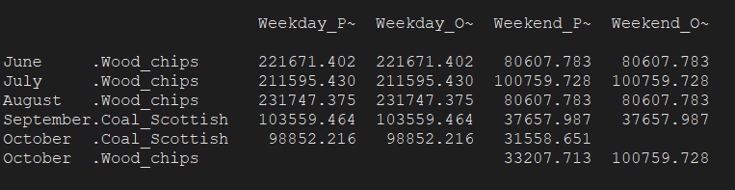

**Table 4.1** For each of four time period in a month with their shadow prices and upper limits

